Trading Plan (inspiration of Feb2865):

Resume :

"I have a hard and fast rule of entering after the pullback is confirmed because my job is to preserve my capital and minimize risk."
"Only pay attention to the price at the close. If you go down to a lower time frame, your job is to look for a price discount. That's it. Every trade must be done at the close...not in a middle of anything."
"Your job is to enter as soon as you see that V formation.... and place your stops and trail them accordingly"
Example of V-formation entry on a pullback
"Trading ranges are irrelevant in my humble opinion. I go down in time frame looking for a discount in price when a range occurs."
Regarding Stop Loss: "If you're looking to place a trade on a 4 hr charts - place the stop loss at the high/low of the previous daily candle. That way you give your trade enough room to breath and time to mature. Don't place them on the same timeframe you're looking to trade. After that, trail the stop-loss using the low/high of the daily candle (low/high depending on where the trend is)"
Regarding Exiting a Trade: "I use the same pattern as if I decide to go in - a reversal/confirmation candle, When that happens, I take some profit and leave some compounding."
Regarding Indicators: "But I learned thru the years that price is king. At the end, nothing else matters. I like my charts plain."
Regarding Timeframes: "I find anything lower than 4 hr is noise. A crude reality of lower time frames is that you're more exposed to news and noise. But it's up to you. I like my life easy."
Regarding Breakouts: "If it keeps moving higher then I sit on my hands and wait for the next pullback."
"Nobody knows how far the market could go so it's better to stay put. I must see a reversal and then a continuation."
"People you don't have to play if you don't want to. Don't let the market manipulate you. If you feel that you missed the bus.. I assure you there will be another ride. Just get on the next one."
"I advocate a lot risk assessment. Sometimes you just have to miss the bus. But when you see an opportunity, go for it. Don't over analyze the charts. You already know what you're looking for."
"I believe as long as you follow the trend you'll be alright."

“You must add two words in your trading
1) if
2) then
for instance
"Based on the information I collected (looking at the charts. establishing corrections, consolidations etc) IF the market do xxx(action = price) THEN I will Buy/sell”
You're combining two elements - Hindsight and "active price action" in one place.
Action – Reaction”

“Is better to become a “student of the markets” better than a “system follower” because the truth is my friend…there’s no system. It doesn’t mean you don’t gotta have a plan….( yes remember “if” then”).

“My goal here is for all of you to have a deeper understanding on the markets so you can make an educated guess with an appropriate risk assessment when the time comes to pull the trigger.”

“The method works you just need to deal with yourself – patience. Talking from experience.”

Methodology:

- Follow the direction of the trend on daily chart.
- Look at the 4H chart
- Buy on pullback and sell on rallies at the 4H chart, keeping an eye on periods of consolidation (white S/R) lines on the daily chart.
- I don't look for a V setup in 4 hr I am looking to buy at discount. I look for price. The V formation is already there on the daily charts.

Example of retracement and possible V formation setups:
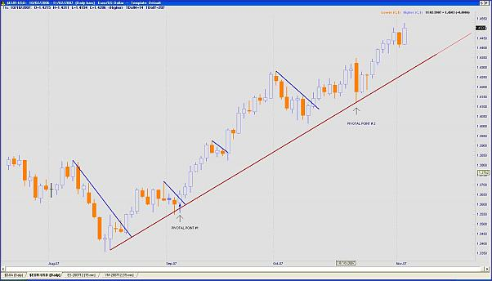

Another example chart of Feb on retracement area and fractal pivot point:
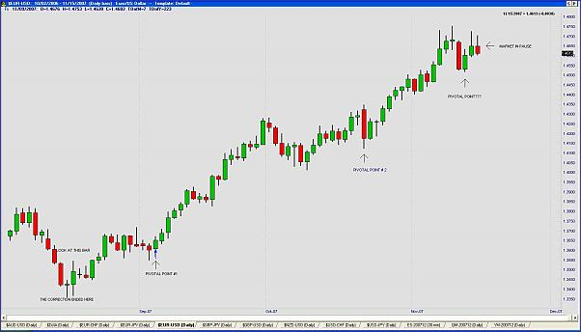

Example of entry according to V formation on Daily chart of the YM:
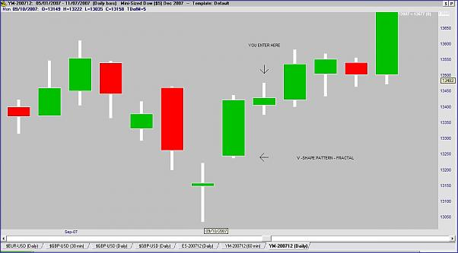
Another entry example:
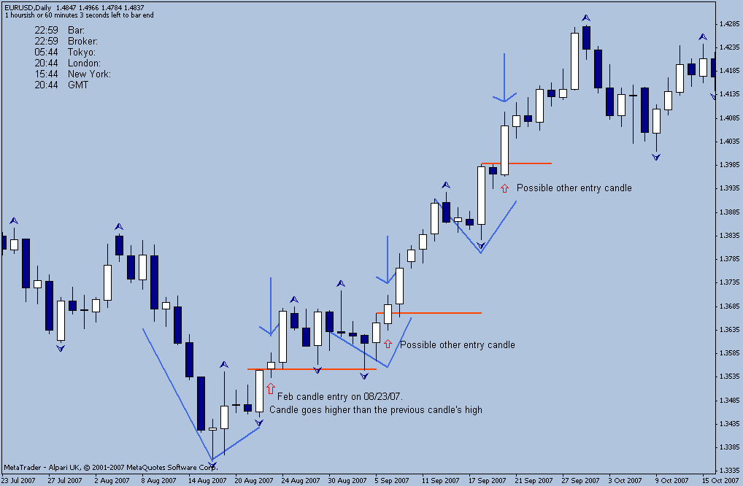
“Exactly how I do it. I wait for the close, and then I enter IF it breaks the higher/high or lower low of the last one. The V-formation has to be there.”

Inter-market relationship:

- Inter-market relationship is truly my edge...The rest is just the mechanics of trading AK entry/exit etc. I always look on who's leading and who's lagging.

Examples of inter-market relationships:
EUR/USD:
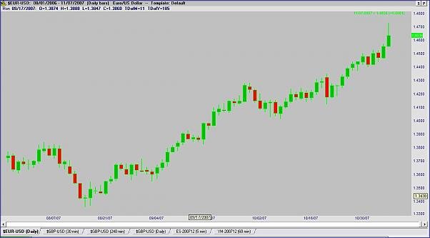

GBP/USD :
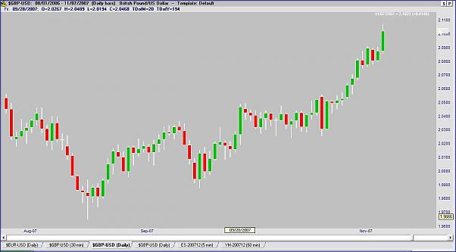

S&P 500 :
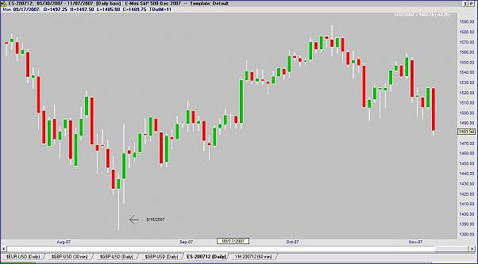

DOW JONES:
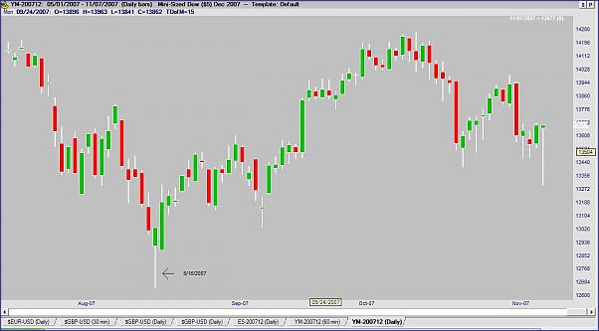

QQQ:
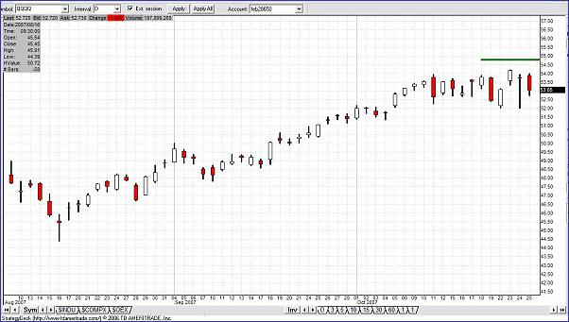
- Every time I find a sweet spot (8/16/2007)...is literally like printing money out of your charts.... How do you find a sweet spot on the markets??? Inter-market relationship....that's it

Feb2865 Plan:

1) I check the indices - I put a lot of attention on DJIA why?? Because I copycat the big dogs - all of them check the DJIA to look for inter-market relationship. When you get the hang of it. Makes a lot of sense. I also check Crude oil/gold to see if they are putting some weight on the indices but that's secondary.
2) Check what reports are in for tomorrow - I am not "jumpy " for news, reports etc. I don't trade them. I don't have to. But if happens that you got everything line up for a trade. Just be aware of the extra-volatility so you don't get stopped out so easy.
3) Check the patterns - what do you see??. Is there a fractal??
4) If there's a V formation, once my third candle has broken the higher high/lower low, then I zoom in to 4hr charts. I am looking for speed/retrace etc. How fast is retracing??? Do I have time to get a good price??
5) If I an looking for a discount price, I set an alarm (starring at the charts for too long gives me headache, seriously) but I also set an alarm at the point where the 3rd candle broke the pattern. Sometimes you can't get the discount and the market is coming back to that point. I tell you, I won't miss the buss.
) I don't wait for the third candle to close... I mean, I have to get in somehow. Maybe I didn't explain myself clear so I apologize. Once the high/low is broken I do my play
Once I have all ducks aligned, I pull the trigger, set my stops, (I also put an alarm where the stop is) I close my charts and I go do something.

Stop Loss:

- Place the stop loss at the daily high and low of the previous day candle depending where is the trend.
- Trail the stop as the trade moves in my favor at the daily high/low of the previous candle (trade has room for breathing).
- Forex options are a good way for hedging the stop loss and minimizing the risk.
- Stop loss - If you're looking to place a trade on a 4 hr charts - place the stop loss at the high/low of the previous daily candle. That way you give your trade enough room to breath and time to mature. Don't place them on the same timeframe you're looking to trade. After that, trail the stop-loss using the low/high of the daily candle (low/high depending on where the trend is).
- Need to adjust it based on risk tolerance, trading capital and position.
- I am super-discretionary on my stop placements. I use swings. It all depends. The idea is to keep your stops away from the fire but not too far away. Sometimes I trail them sometimes I just let them put. I check on them every day.
- Guys you need to assess how much risk you're willing to tolerate. If the swing is too high, then just lower your gear. Somebody told me once that there's a broker outhere that allows you to trade by units. I think that's wonderful. Have a calculator handy for that. You go like "well the swing is 150 ticks( where I should place my stop), then according to my x % of my capital and my risk tolerance (emotional risk) I am willing to risk $$$$$....or ...that's too much I will wait for the next bus.
- Daily low candles are good just be careful about news, reports etc, on the following day. They can shake you out of position just measure how long it is. If can use a swing even better.
- It all depends. I generally build a position for a long term if the market has what it takes. Then as I see a confirmed fractal, I decide if I scale out, add some more funds or simply shot the trade completely. At the beginning you can either go all in (always with an eye on capital risk) or just build your position over time in increments of x amount of contracts/lots/shares. etc.

Profit taking:

- Let the market close my position by hitting my trailed stop loss. 2 things can cause this: 1) a deep retracement and 2) a valid reversal of the trend.
- About profit taking, well depending on market conditions and money management rules, I scale in or out at every correction.
- I use the same pattern as if I decide to go in - a reversal/confirmation candle, when that happens; I take some profit and leave some compounding. But you don't have to do that you can close all take some and get in on the next ride. There's room to play.
- Or I just get stopped out hopefully in profit. I believe as long as you follow the trend you'll be all right.

Examples of where of potential areas to either close the trade or areas to look for a new V formation setting up in the future:
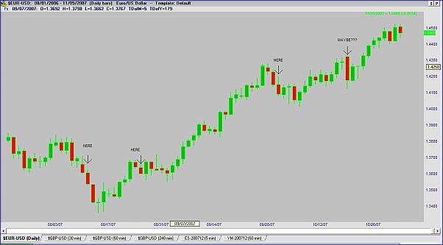

Timeframes:

- Daily chart for trend direction.
- 4H chart for looking for the entry.
- I personally think anything less those 4 hours is noise, especially in forex. It's something you need to see for yourself.
- A crude reality of lower time frames is that you're more exposed to news and noise. But it's up to you. I like my life easy.
- Another reason I prefer daily charts is because I get enough information from the market about trends. Corrections etc. and the market has an already digested any news, report etc.
- Weekly time frames are useful, definitely. I just prefer daily charts because I have all the data I need to make a decisions, most of the time. Of course sometimes, daily charts data are not enough so you must go to a higher time frame.
- I know trading on higher TF's can be a real emotional ride. It takes patience and discipline to be able to enter a trade, experience some drawdown while it develops and then either recognize that it's not going to work out in your favor and close at a loss or follow it into profitable territory.
- I don't have a clue about how forex brokers operate. Make sure your broker's clock is set at 00:00 GMT That could create a huge difference in your trading especially if you're looking to ride the bus early.
- The way I look at the timeframes is to think of them as a magnifying glass with various strength settings. Sometimes the picture is so clear from the monthly or weekly charts that I don't need to zoom in further and can take a position (longer term one of course). However, sometimes I need to look more closely at what makes up those bars/candles and this is where the daily, 4Hr and even 1Hr charts are necessary. This might sound crazy but you can look at two daily candles that seem identical but, zooming in closer, the internal structure of those candles (demonstrated by the 4Hr or 1Hr for example) can be very very different and will impact my decisions

Fractals:

- Go to Page 12, and read the first paragraph (and click on the link) in my first post where it brings up feb2865's post where he drew his lines for the pullbacks.
Then scroll down to the bottom of that same page to Post #180 and you can see by the example chart how the Fractal depicts the similar pattern. It basically points out the highs and lows of turnaround points, so it more-or-less acts as a confirmation to the direction of the price action. On an uptrend, when the price action breaks through the "Up" (green) Fractal dots, that more-or-less confirms a breakout (and visa versa for the "Lo" (magenta) Fractal dots). I say "more-or-less" because as we all know, nothing is engraved in stone, and the market can change direction at anytime. But most of the time, I've found, that indicator serves good its purpose.
- Fractals works more often than not. It's a way for you to see if the market has intention to resume the trend or to be sloppy. But I got burned BIG TIME (capital letters) on fractals before. Because my job description includes "Risk assessment" I decided for the fractal to be confirmed. I rather leave some money on the table that gets burned.
- About implementation of what I presented here in other markets etc. I have to respectfully disagree. I believe as long as there's supply demand on the markets, there will be natural occurrences (like fractals / Support and resistance, choppiness etc) in which every trader armed with proper knowledge an uncluttered/ unbiased vision of the markets could capitalize upon. This rule applies to all markets, including your local supermarket.

Examples of fractals:

Desktop version of Intellichart of Leighsww fractals example:
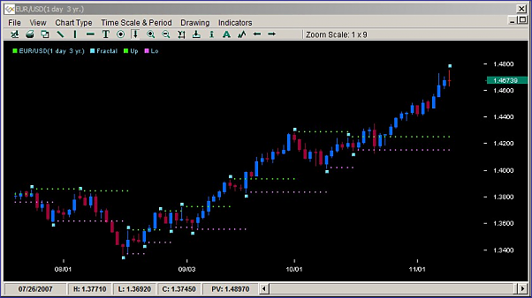
MT4 fractals example on Daily USD/CHF chart:
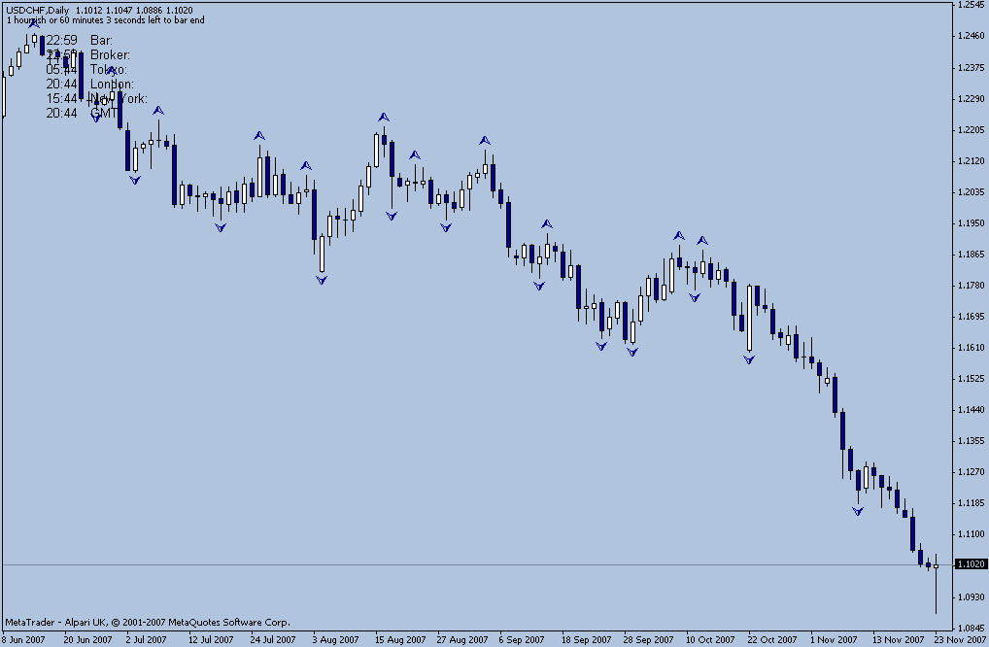

Example of the importance of fractal confirmation before taking any new trade:
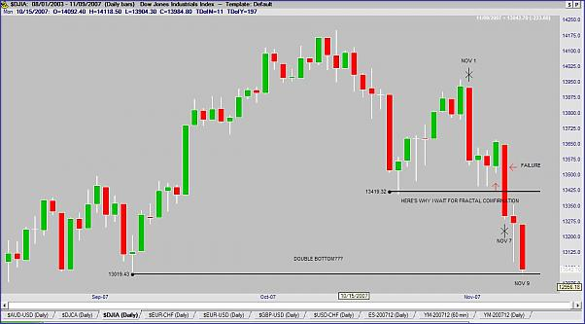

Another great example from Feb on the importance of only looking for a clear and well-defined V formation before taking any trade. Look his chart of EUR/USD Daily and see how there is no candle confirmation to enter a trade. After the doji candle of August 1st 2007, we need to wait 2 candles before to have a daily close above the high of the doji candle. Even after that, there is no candle going really higher than this second candle, so no trade. Look for the deep retracement following it. Lesson, sitting on our hands is always the best solution when there is no clear high probability setup:
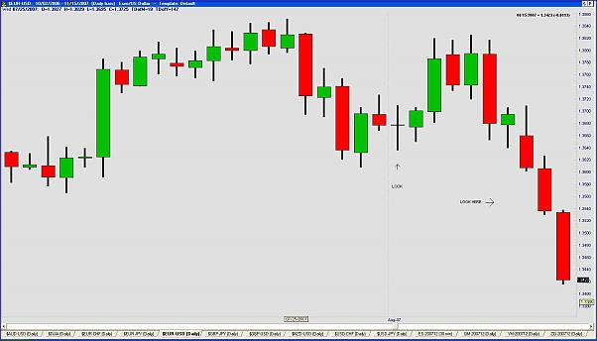

Breakouts:

- As for how I deal with false breakouts, I tend to avoid trading breakouts in the main. Of course, there are always occasions where a breakout interests me (based on the preceding market structure) but I would usually wait on the retracement before getting in. Sure, sometimes there is no retracement and it just keeps going but I'm happy to let those ones go rather than chasing the market.

Example of false breakout from Feb chart of AUD/USD:

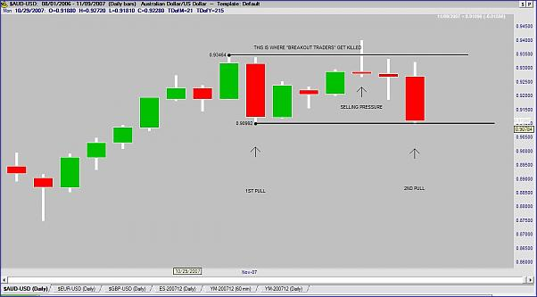
Great example of Old Not Dead false breakout of EUR/JPY Daily:
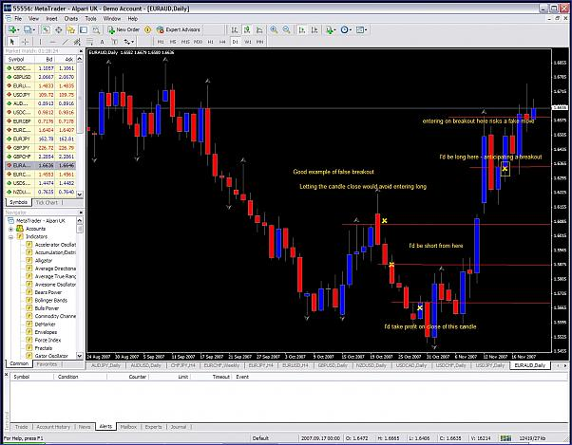
Trader_V example of playing EUR/USD breakout:
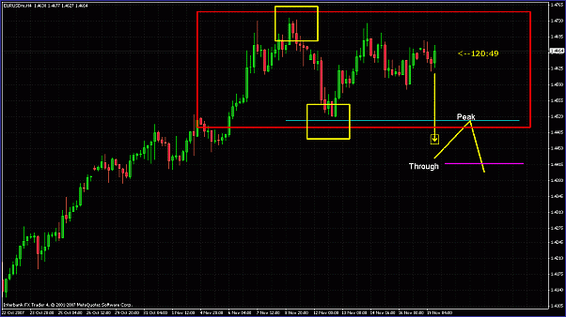
Another example of Trader_V of how to play a breakout by waiting for a retracement before entering. Chart based on Old Not Dead previous post about how to position’s oneself by waiting for a retracement after a breakout occurred:
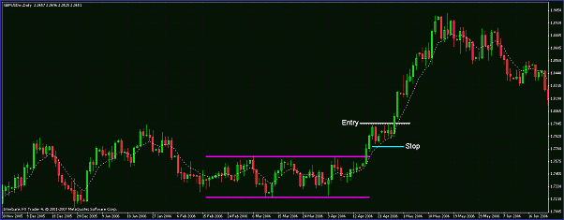

Wisdom tips of Feb2865:

1. No setup = no trade. Stay focus; don’t get fooled by the noise of the market. You know what to do.
2. Once you have a trade with stops and everything stop starring at the charts. Go do something else. I mean, you already have a trade; the market is not going anywhere.
3.There will be a point in your trading career that you need to stop "listening" to others and start listening to yourself. (Don’t you think is about time now??)
4.If you get stopped out, deal with it. There's something called market risk, which is the reason why the Holy Grail doesn't exist. You chose this career. If you can't deal with a loss, Wal-Mart is always hiring.
5. When you get bored to death, will be a sign that your trading is improving.
6. You must be attentive to risk and stop thinking about how much can you make. Don't worry you'll get paid.
7. If you're looking for excitement, go to a casino. Trading is hard, cold and lonely.
8. Stop this "optimization process" Seems like a never-ending story to me. I mean, there will be times where you're gonna get burned. The problem lies in you getting discouraged and start this " let me throw some big macs or stochs to "optimize" I assure you eventually that will lead you only to frustration.
9) Don’t be like a monkey jumping from one tree to the other looking for something that "works most of the time". You know that's bullshit. You're lying to yourself. The truth is that you are not capable to follow your vision. At the end, your account is up in the wind. It's time to stop.
10) I've seen plenty of traders, practicing on demo for a hundred years. You're scared my friend doesn’t deny it. Here in forex you can trade even for pennies. It's time to get your ass on the line and get real my friend.
11) The market is nasty. Take no prisoners. And won't care if you're good or not. Don't let it tell you what to do. You call the shots. If you feel that something is not right, insecure, sick, out of focus, etc. Don't trade. Don't force anything
12) Relax. You're trading off the daily chart. Take your time. Think. Observe. Be picky with your trades. Take the best setups.
13) It's good to have an attitude when you're about to trade. I was an asshole when I was on the floor. Now in front of the screen I still have an attitude. Remember, it's your money and your time and you're a professional. The time to be a newbie is over and will end on this thread.
14) If you miss the bus, that's ok. Don't be hard to yourself. As long as demand and supply rule the markets, I assure you there will be plenty of chance to get back on the bus.
15) The most important rule of all - help others. Pass the good Karma and it will comeback to you bigger Talking by experience. You might not agree with me and that's ok. But it took me many years to understand what I just stated above. I am practical. I trade for the money that's why I play smart. Risk is my #1 priority. I managed to keep my head above the water since 1981 doing what I said above. I believe you can do it too.

Great psychological trading tips:

- Trading do not need to be complicated, keep it simple, and it is supposed to be boring.
- Stop going from one system to another to another . The “wholly grail” do not exist.
- Stop depending on others for your trading decisions, be responsible and make your own educated decision on your trades.
- Listen, none is capable to predict where the market is moving next. We can only make an educated guess.
- The idea is for you guys to start looking at the market, as it is...a big-ass auction where price is the only consideration involved.
- But I learned throughout the years that price is king. At the end, nothing else matters.
- Be smart. Buy on strength. Sell on weakness...after you confirmed the direction of the trend as I stated before.
- Yes trading should be boring. Well, some traders have the necessity to pull the trigger all the time, because subconsciously they MUST be at the market constantly in order to make a living. They end up chasing the market and forgetting about their strategy. That's a recipe for disaster.
- If you want to be in profit-land, you need to be the predator.....like a cat moving the tail in front of a mouse. Wait for the right moment to jump in. It is sometimes boring to be the predator...very boring...but it works...just try it.
- The whole idea is for you guys to have a clear and unbiased view of the market.
- As long as you have your stops in place, you just go with the flow. Make your life easy.
- TRADE TO LIVE, NOT LIVE TO TRADE. (Best advice I ever received. Before that, I was scalping all day, and therefore wasting most of it in front of a computer.).
- You need to position yourself as what you want to accomplish in this business. Time horizon, profit larget etc.
- Don't marry yourself to anything or any market. Be diverse. I know this is a forex forum and everything but will be nice for you to learn about equities, bonds etc. Think outside the box.
- This is a long race, not a sprint.
- Real players are the one's who take the market, as it is - a big auction. They read price and act accordingly. My challenge to all of you is to start thinking differently.
- Just take time to understand what's going on. Be an avid student of the market, not a system - That's why I named this thread with irony.
- All begins with price. Once you get the hang of it, you feel that you're in business. Don't take my word and try it.
- I am not here to patronize a system. I would like to help people learn how to read the market thru price and also develop their own view. Don't take my word of anyone for granted. I am only bringing experience on the table that's it. Draw your own conclusions on the market based on analyzing and research of the markets and I bet you will have success in the long run.
- It all starts as looking on the market as a big auction. I will never get tired of saying this.
- Stay away from round "key" numbers i.e. 1.4500 - 1.4600 etc - there's a lot of sharks on these waters waiting to hunt your money down. Let the market move away from there. This is applicable to ALL markets. I was on the pit I know this from experience. Forex is no different on this matter.
- You call the shots. Not the market.
- Losses are part of the business some days you turn a profit other days you turn a loss but it's the number that you end up with in the long term that matters not the day-to-day Profit/Loss numbers. So get out move on and find the next good Setup.
- NEVER NEVER NEVER attempt to justify my entry after getting in the market. And you should never justify it either. If my justification for getting in the market is not set before entering I should not enter. Know what your plan of action is before entering and after entering.
- Make sure you qualify your setup. If you missed the bus, there will be another one. If you see the pattern, go for it, don't think twice.
- Consistency is such an important factor, in my opinion.
- This is why I believe that the higher efficiency rate of successful trades happen with trend trading on longer-timeframes and sticking to that rule!
- Trends in my opinion don't need confirmation the trend is either there or not. Just train yourself to see naked charts.
- Many times we can see what mistakes other people are making, but we don't see our own mistakes as clearly for ourselves.
- We need to learn patience, because when the trend resumes, that's where the money will be made. The more I come to study the charts and look at this system, the more apparently clear it becomes.
- You’re a trader. You must pull the trigger when opportunity knocks…right??
But you must also have reasoning behind your trade. This is the secret of my endurance on the markets. I know what’s going on. Because I know I call the shots. I am not “married “to a market. I am married to an “opportunity”. Talk your yourself.
- "Waiting for the right moment, and ride on immediately, don't hesitate, otherwise you will be too late".
- Trading can play on your emotions a great deal. You must be a machine when it comes to winning and losing positions. Emotions have no place in the market!!! When you can take a win the same as you take a loss in the market this is when you have control over your emotions and prevent from making emotional decisions based on fear or greed.
- We need market imbalance in order to make money. Remembrer that.
- Trading long-term, longer-timeframes and with price action is the key, this I have no doubt.
- Every day I start by telling myself its ok if I don't trade at all and that "patience to wait for the odds to stack in my favor is the MOST important part of trading."
- Be the predator, not the prey. Patience plays a big role on this business.
- Just remember, ultimately you're calling the shots. That's why I don't get attached to any market.
- You just try to make an educated guess based on market conditions.
- My friends take note, this is a classic. The soap opera of those who sell hard into the close most of them for a loss...and the sharks saying "come to papa!!!! A never-ending story. Yes, that includes E/U and some others, I haven't look other charts...I bet the cable went down as well HA!!! ..Don't let this situations fool you. You know what you're looking for. Stay focus. Play smart. Be strong.
- I would like to let the new guys know this is all right. In fact, if you can learn not to trade during times that are so chaotic, you are learning. Learning NOT to trade is just as important. (I swear I know this.)
- Let me tell you my friend, you can trade one setup and be wildly profitable and make a comfortable living from just that one thing alone. So find one that you understand learn it and learn it well. Understand its nuances and mannerism and you will soon be on your way to making excellent trading decisions.
- The method works you just need to deal with yourself – patience. Talking from experience

Useful questions to ask oneself:

- Why the market is moving in a certain way?
- What are the forces that moves (shifts) the markets between supply and demand?
- Once you have your setup in place, don't be trigger-happy. Use the words if then in your trading? If the market reaches x price, then, I'll be a (buyer/seller) you call the shots. Not the market.
- It is no big secret that making trades in the direction of the primary trend presents a trade opportunity with the highest probability. So the question is going to come anytime now about how do we determine the trend? What time frame is most reliable and so on and so forth?
- So ok the big question is how do I define a trend? I use price action to define a trend base on the classic definition of higher highs and higher lows for an up trend and lower highs and lower lows for a downtrend. So by treating peaks and valleys as 1-2-3 points poises me for catching a trend.

Support and resistance levels (S/R) and trendlines and fibos:

- They're good as long as you use them as simply as guides.
- I use S/R lines to identify bull flags and consolidation patterns.
- Never trade only based on them.
- Support and resistance - correction and continuation - will never go out of style as long as there's supply and demand.
- In my case, I learned that it’s more important to understand intermarket relationship better than “market sentiment” or “what’s better candlesticks or pin bars” trend lines, fibs etc. They’re just guides. Don’t patronize them or I assure you, they will get you killed in the long run. I use them as I said before. But I don’t rely solely on them for trading. Actually, many times I use S/R levels looking for clues as to where they (big dogs) could trigger stops and avoid these areas (notice that I mentioned areas instead of price).
- If you look closely on real time, many times when the high/low of the day is taken, there's plenty of time to get the discount in price. I mean, you have 4 hours. Also the high/low of the day , more often than not you're going to notice a "fast market" once the market reach theses levels. There's a retrace like a small pullback and then a continuation. Could be a small correction I don't know. You can't see that on hindsight. Many sharks are positioned in these levels to trigger stops. Not only at pivot points or S/R lines as some believe. Hence the fast move. I wait for the smoke to clear and try to get the price at discount.
- Something about pivot points/ S/R lines, fibs. Etc Never place stops at these levels. Too many sharks in these waters (myself included, not in forex but in some other markets) By the way, I have to give credit to Mr. Trend on what he said about placing stops like 20 pips away from daily bars. As I mentioned in one of my earliest post, I use them, including trend lines. But I don't worship anything on my charts other than price.
How do I use them?? Well, very simple, looking for clues on what others are doing. I track speed and momentum on these lines. Also to have an idea on where not to place my stops. That's it.

Reasonning for decision making on a trade:

- Trade off weakness/strength = pullbacks and rallies - in other words = price. But the pullback- rally needs to be confirmed by a continuation pattern.
-The market must show intentions to re-establish the trend; meaning a break of the higher/high or a lower/low. Let the market come to papa - don't go chase it...stay put. Wait for the break.
- I prefer to leave some money on the table, just to make sure the market has intention to resume what it left behind.
- I look at what's been going on historically on whatever I decide to trade.
- Another thing to consider: Big players are looking into "key prices".
- Another thing I look for is inter-market relationship:
- Crude Oil - USD/CAD
- USD/JPY - Mini DOW (YM) or any of the e-mini's for that matter.
- I refine my entries on the 4 hour charts just to get a better deal (price speaking).
- The key element here is a confirmation of a fractal.
- Follow the trend and let the market prove itself and show you entry areas and exit criteria based on price action.
- Actually I keep my heads up for spinning tops/hammers. I don't trade off them; just I used them as a warning. If I see a hammer on a daily chart I still go lower to check the quality of that pattern. Looks can be deceiving you know.
- You need to preserve your capital, having a high-probable entry and managing your trade away from the fire i.e placing your stops too close.
- I've found that in my trading it's best for me to trade with the trend, understanding the general fundamentals, and keeping an eye out on policy shifts.
Policy shifts don't happen overnight. So traders shouldn't think that, for example, this recent $ buying means the trend (in respect to EUR) is over... far from it IMO... That's why I'm a buyer in the 4400 area... after price confirmation of course...
- I don't over analyze charts. I look for conditions only (trends, corrections, selling pressure, fractals etc.) and then I make my decision.
- After I place a trade, other than trailing my stops whenever are a chance, I do nothing. I let the market do whatever. I don't have my eyes "glued" on the monitor(s). I know this is probably the hardest part for plenty of traders but you gotta do it, there are no shortcuts.
- Observe hammers. Also is good to pay attention at shooting stars. Just remember, I used the following words "observe" and "pay attention". The idea is to be careful.
- My big rule is to look at the overall context of the price action and what the market structure looks like up to that point in time. I'll try to explain that more explicitly in a second but first I should clarify that, for me, a candle that hasn't closed yet could end up being anything and I'd usually wait for the close.
- For me, when a key level is broken I am alerted to the fact I might get in. I'd usually want to get in on a retracement or on an exceptionally bullish closed candle.

Anatomy of the trade:

- Reversal formation in a pullback in an up-trend and a rally in a downtrend.
- V shape formation.
- Your job is to enter as soon as you see that V formation.... and place your stops and trail them accordingly; don’t be a fool and get on board thinking that a correction has ended. Risky business in my opinion. Make sure the trend has resumed. Remember...always look for that V pattern.
- 4 hour charts are some sort of a " looking for a sale (bargain)" window. When the high of the last daily candle in a pullback is taken out, you look to buy at a “discount” in the 4H chart at a lower price.
- Fractals can be deceiving. That's why I need for the market to "confirm" the move for me in order to get in.
- I must see a reversal and then a continuation.
- Look at the big picture. Not just the pullback, be on the lookout on what happens next. Also, I am on the lookout for periods of consolidation.
- Yes absolutely, everything must be done at the close.
- "Pivotal points" as been a fundamental part of my trading.
-Once the market has broken the "box" wait for a pullback at a lower time frame. Don't go blind chasing the market, that's what everyone does and believe me there's a lot of sharks out there waiting on "breakout traders" to hunt them down. Play smart. Make sure the market has intention to resume the longer time frame. Wait for the market to come to you...AND ALWAYS WAIT ON THE CLOSE (yes capital words included) don’t play in the middle of the move.
- I do not like to fight the power (the trend) so I go with the flow and enter on the most basic of all formations 1-2-3.

Example of the great 1-2-3 method of Trader_V:
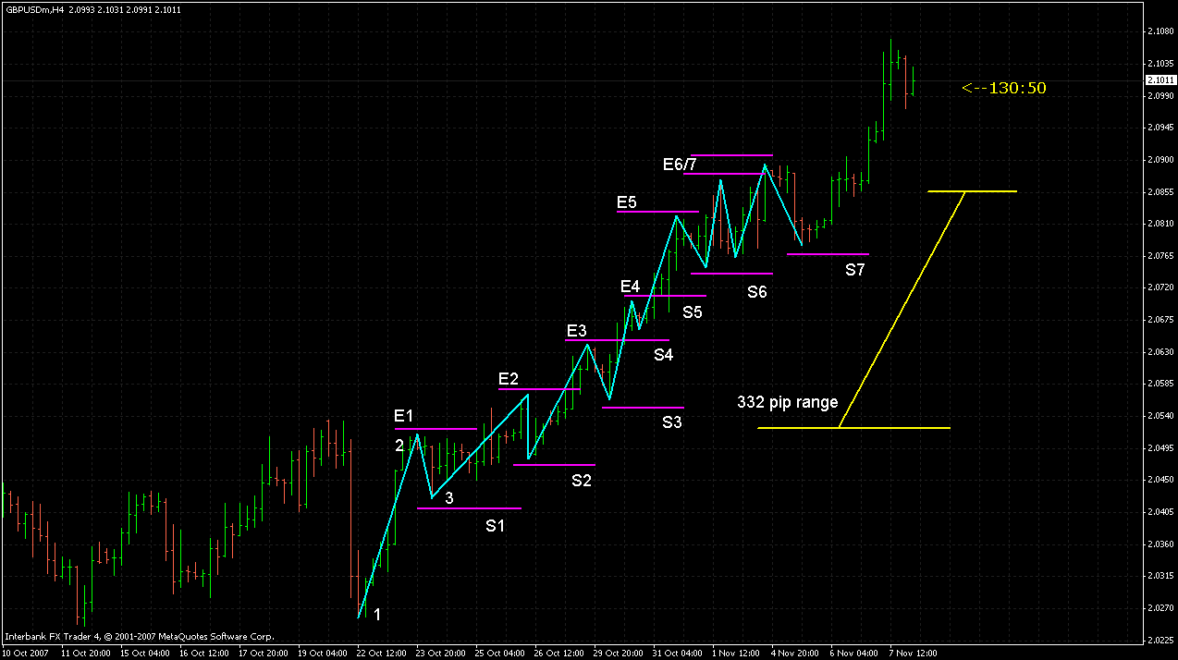

Another example of a chart of Trader_V 1-2-3 formation:
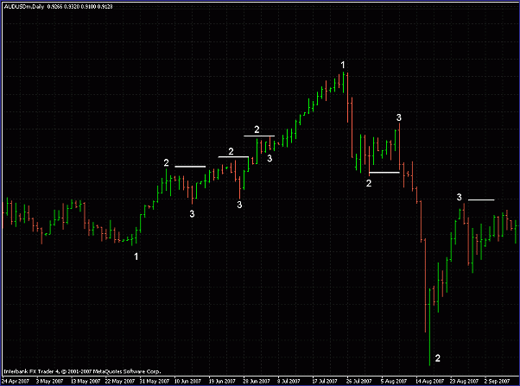
- I have a hard and fast rule of entering after the pullback is confirmed because my job is to preserve my capital and minimize risk.
- It's better to leave some money on the table than get yourself burned in the middle of a correction. Play safe. Don't trust the market.
- Only pay attention to the price at the close. If you go down to a lower time frame, your job is to look for a price discount. That's it. Every trade must be done at the close...not in a middle of anything.
- Yes entry would be at the next candle if it breaks the higher high/lower low depending on where the trend is. In order for you to have a valid pattern you must wait at the close of the candle.
- Again an excellent point. Although I make my primary entries on the 4H charts I do refer to the Daily and Weekly charts for areas of S/R that may clue me into profit targets and stop loss areas. And very similarly as you do, I try to glean trend information about direction and pullbacks.
- You need to read price action ******as is happening*****. At the moment you see a V pattern formed...go for the killing.....not later.
- Don't over analyze the charts. You already know what you're looking for.
- For now lets keep things moving in the right direction by understanding that we are looking to enter trades in the direction of the trend with an entry point based on a price action setup after a pullback or a break of he most recent #2 point after a pullback for you more conservative types like myself.
- I trade off confirmed fractals. If I don't see one = no trade. As simple as that. That's my hard and fast rule.
- Pinbar or a bullish outside bar forms, you better believe I'm gonna play that setup... because I know those setups work....
- Yes I wait for the third candle - that minimizes risk...It is not a holy grail, just reduces risk in my opinion.
- Exactly how I do it. I wait for the close, and then I enter IF it breaks the higher/high or lower low of the last one. The V-formation has to be there.
- My "play" on the 4 hour charts is when the market has broken the higher high/lower low I am looking for. Remember I play conservative in order to minimize risk as much as possible.
- For instance, within the 4hr, you might see a small little retracement and that's where he may pick his price, yet it's not affecting any type of retracement in the Daily chart because it's only making a difference in the 3rd candlestick that we want to get in at.

Consolidation:

- If the market keeps going, I add to my position.
- If I see like two lower lows, then I might scale out.
- Trading ranges are irrelevant in my humble opinion. I go down in time frame looking for a discount in price when a range occurs.
Example of consolidation. Potential breakouts to either side:
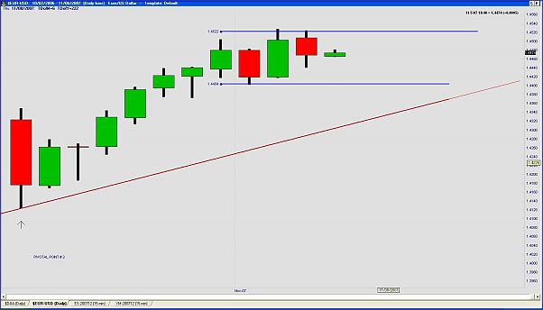
Another example of potential breakout on EUR/USD Daily chart:
